EXP 18 : SIMULATION OF DSSS COMMUNICATION SYSTEM WITH PN CODE GENERATION AND SIGNAL RECOVERY USING MATLAB
SOFTWARE USED : MATLAB SOFTWARE

CODE :
clc; clear; close all

N=10; L=7;
bits=randi([0 1],1,N);
pn=2*randi([0 1],1,L)-1;
data=2*bits-1;

spread=kron(data,pn);
rx=spread;
recovered=zeros(1,N);

for k=1:N
recovered(k)=sign(sum(rx((k-1)*L+1:k*L).*pn));
end

detected=(recovered+1)/2;

subplot(4,1,1),stem(bits,'filled'),title('Original Data'),grid on
subplot(4,1,2),stem(pn,'filled'),title('PN Code'),grid on
subplot(4,1,3),plot(spread),title('DSSS Spread Signal'),grid on
subplot(4,1,4),stem(detected,'filled'),title('Recovered Data'),grid on

disp('Original Data:'); disp(bits)
disp('PN Code:'); disp(pn)
disp('Recovered Data:'); disp(detected)
fprintf('Bit Errors = %d\n',sum(bits~=detected));

MODEL GRAPH :
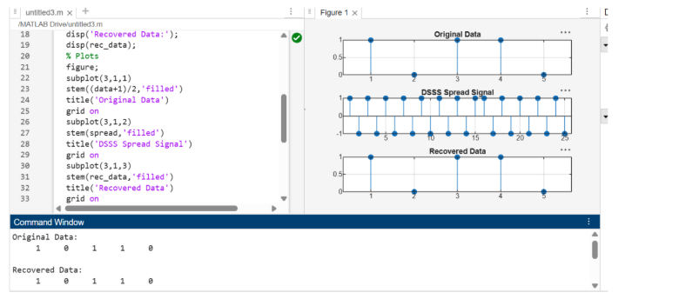

RESULT :
